**EE 352 - Communication Systems - 1**

Hardware Laboratory Report-2

**Frequency Modulation and Demodulation**

**Şule Zeynep Parlat: 260206062**

**Ferhat Böcek: 260206070**

**Onur Bodurer: 260206072**

**Abstract**

In this experiment, we observed the state of FM Modulation and Demodulation. Our experiment consists of 2 parts. By using 2 LM565s as integrated circuits, FM modulator and demodulator circuits are designed to operate in the VLF band at a carrier frequency of 100kHz in the first part.

One of the LM565s is used to generate the FM waveform while providing the voltage-controlled oscillator (VCO) of the PLL, and a second LM565 PLL is operated as the demodulator.

**Introduction**

The first component of this experiment generates an FM signal. LM 565 generates an FM modulated signal using a voltage driven oscillator. In frequency modulation, as the amplitude of the message signal grows, so does the frequency of the modulated signal. When the amplitude of the message signal falls, so does the frequency of the modulated signal. As a result, (modulation index) determines the frequency of the modulated signal.

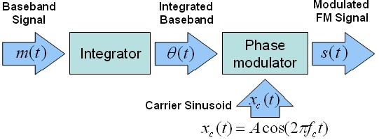

**Figure 1:** FM Transmitter Block Diagram [1].

As shown in the block diagram above, the integration of a message signal yields an equation for phase with respect to time. The following equation defines this equation:



In AM modulation, which we learned earlier, there is a changing carrier amplitude and fixed frequency while transmitting the message signal, while in FM modulation, our amplitude and fixed frequency are variable. In FM modulation, the carrier signal is chosen sinusoidally for transmission and reception, but sometimes the carrier wave can be square. The transmitting signal is expressed as:



$∅_{i}\left(t\right)$ (initial) 🡪

🡪 (Instantaneous frequency for FM)

🡪 frequency sensitivity

🡪 the carrier frequency

After these expressions, we can express the FM modulation with this formula:

$$s\left(t\right)=A_{c}*cos⁡(2πf_{c}t+2πk_{f}\int_{0}^{t}{m\left(t^{'}\right)dt^{'}})$$

If message signal is also sinusoidal signal, such as;

$m\left(t\right)=A_{m}cos⁡($ $2πf_{m}t$).

After, transmitting signal will become;

$$s\left(t\right)=A_{c}*cos⁡(2πf_{c}t+\frac{k_{f}A_{m}}{f_{m}}\sin\left(2πf_{m}t\right))$$

The modulation index β is;

🡪 The amplitude of message signal

🡪 The frequency of the message signal.

Based on the modulation index, there are two forms of frequency modulation:

* 🡪 Narrow-band Modulation
* 🡪 Wide-band Modulation

**Prodecure**

**Part – 1 Fm Modulating**

First, we set up the circuit in figure-2. We adjusted R3 until we get a 100kHz carrier wave to the FM output of the circuit. We found the value of R3 to be approximately 4kΩ.

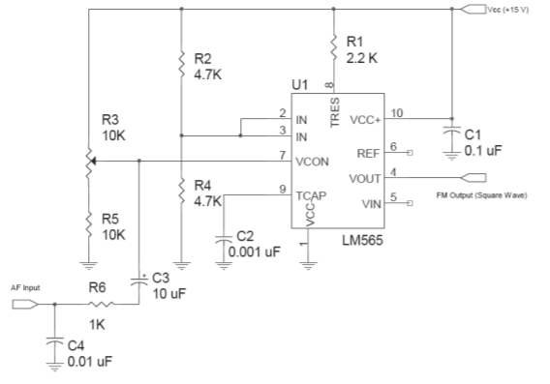

**Figure 2**: FM Modulator employing the LM565.

Then, we set the AF INPUT for a frequency of 5 kHz and a peak-to-peak voltage of 4.5 V.

**Part – 2 Fm Demodulating**

We set up the circuit in figure -2 for the demodulator operation. To tune R106 first, we set the VCO output on pin 4 of the LM565 PLL to be 100 kHz.

Then we observed the demodulation by connecting the output of the modulation circuit to the input of our demodulation circuit.

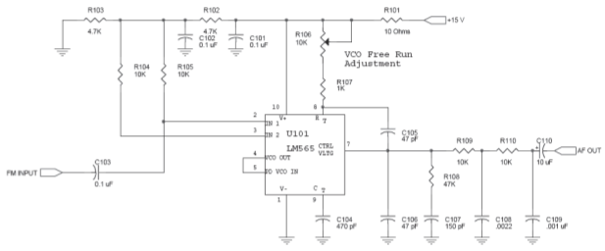**Figure 3**: FM Demodulator using the LM565 PLL

Also, Pinout for LM565:

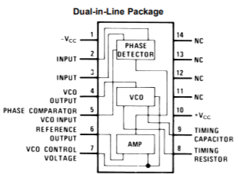

**Figure 4**: Pinout for LM565

**Results and Discussion**

**Part – 1**

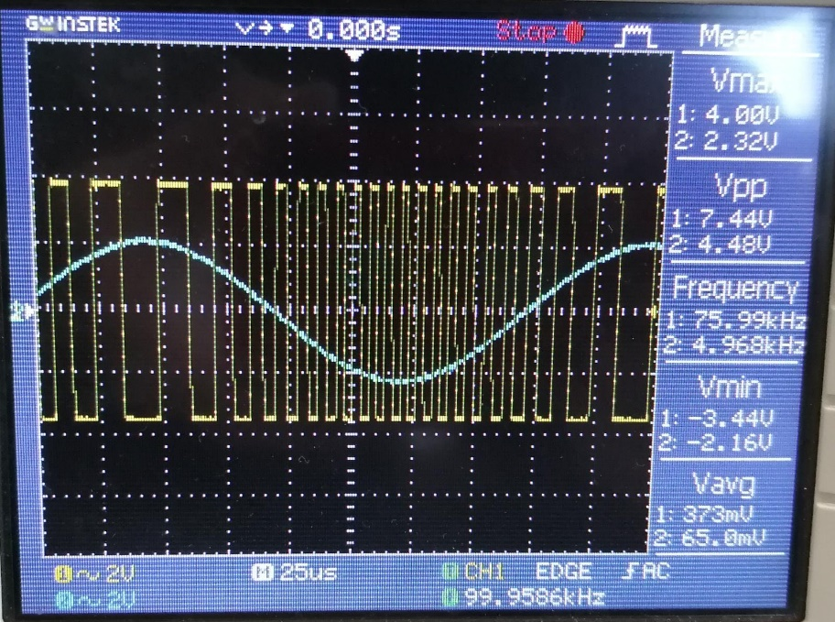

As a result of frequency modulation, we see two signals on the oscilloscope screen. The blue sinusoidal signal is the message signal. The yellow square wave signal is the modulated signal. We observed that the square wave modulated signal at the negative peak of the message signal became more frequent, that is, its frequency increased. We think that the modulated signal increases in frequency due to the negative sign. One of the main purposes of our lab experiment is to control the oscillation frequency with a voltage input. Therefore, we observed that the input voltage of the VCO is of lower amplitude when the output frequency is lower.

fo =0.3/((R3 + R5) ∗ C2)

100kHz =0.3/((R3 + 10 kΩ) ∗ 1nF= R3 = 4kΩ

**Part – 2**

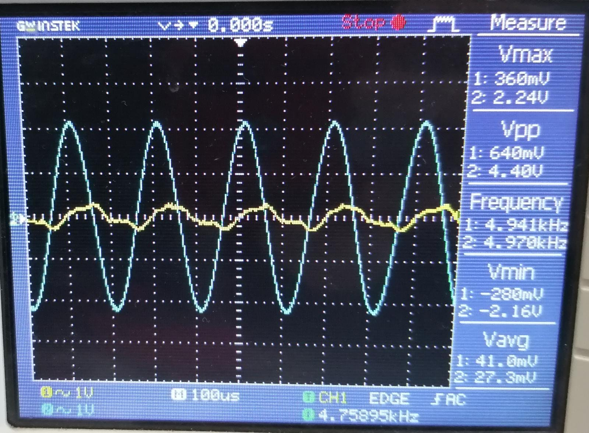

The second part of our experiment was frequency demodulation. The blue sinusoidal signal is the message signal and the yellow signal is the signal obtained as a result of the demodulation process. Ultimately, the goal was to perform the demodulation process to recover our message signal. However, the demodulated signal had some degradation compared to the original message signal due to the noise created by the circuit elements.

**Conclusion**

Results and Conclusion:

•What characteristic of the carrier is varied during Frequency Modulation.

Cycles of the message signal cause the carrier signal to stretch or contract. In this experiment, we observed that the carrier signal narrows in the negative cycle and elongates at the positive peak.

•Explain the role and the importance of R3 in the FM modulator.

We changed the R3 potentiometer resistance value to change the frequency of the square wave carrier signal. Thus, we were able to obtain the desired frequency.

•Explain the effect of the voltage at pin 7 in the FM demodulator (LM565) on thetracking of the original information signal?

We used resistors and capacitances on pin 7 to be able to perform the filtering. Thus, we were able to obtain a low-pass filter. Thanks to this filter, we were able to reduce the oscillation at the output.

**References**

1. “Frequency Modulation (FM)”, https://www.ni.com/en-tr/innovations/white-papers/06/frequency-modulation--fm-.html